Baddha konasana (Cobbler Pose)

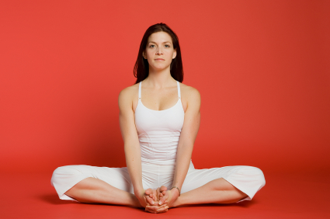
Steps
- Cobbler pose steps are as follows:
- Sit on the floor with your legs straight. You can raise your pelvis on a blanket if the groin or hips are tight.
- Bring the soles of the feet together towards the pelvis and hold the ankles.
- Hold the big toe of each foot with the first finger, second finger, and thumb of each hand. You can also use each hand to grip the ankles or shins if it is not possible to reach the toes.
- Do not push down on the knees. You can put the cushions under the sitting bones to balance the pelvis.
- Exhale and slowly double up forward, stretching your spine as you do so. Maintain the length of your torso and stretch as far as you can do so without any strain.
- Stay in the pose for 1 to 5 minutes; inhale and slowly sit up.

Benefits
Great for hip joint, thigh and pelvic flexibility.
Can stimulate your abdominal organs and kidneys
Tones bladder and reproductive organs and can help with menstrual issues.
Stimulates blood circulation and can benefit mild depression, anxiety and fatigue

Limitations
Groin strain, knee injury or tight hip joints.
Modifications
Sit on one or two yoga blocks to help raise the pelvis. This pose can be practised from a supine position (Supta Baddha Konasana).

Tips
Place the fingertips on the floor to the back of the body to lift the back.
Sit with your back to a wall for added support. Take the feet further away from the body for knee problems.

